**Passing parameters to routes**

There are two pieces to this:

1. Pass params to a route by putting them in an object as a second parameter to the navigation.navigate function: navigation.navigate('RouteName', { /* params go here */ })
2. Read the params in your screen component: route.params

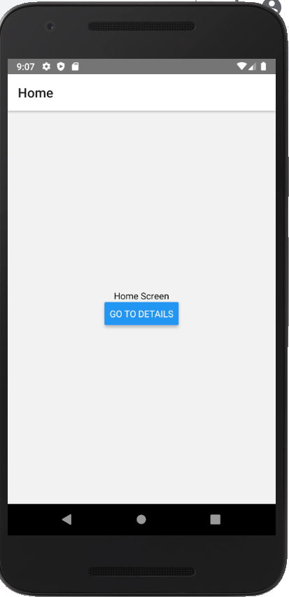 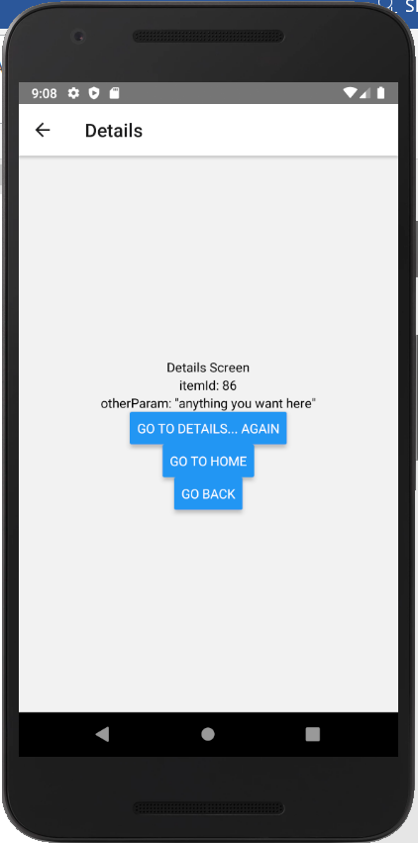

import * as React from 'react';

import { Text, View, Button } from 'react-native';

import { NavigationContainer } from '@react-navigation/native';

import { createStackNavigator } from '@react-navigation/stack';

function HomeScreen({ navigation }) {

return (

<View style={{ flex: 1, alignItems: 'center', justifyContent: 'center' }}>

<Text>Home Screen</Text>

<Button

title="Go to Details"

onPress={() => {

/* 1. Navigate to the Details route with params */

navigation.navigate('Details', {

itemId: 86,

otherParam: 'anything you want here',

});

}}

/>

</View>

);

}

function DetailsScreen({ route, navigation }) {

/* 2. Get the param */

const { itemId } = route.params;

const { otherParam } = route.params;

return (

<View style={{ flex: 1, alignItems: 'center', justifyContent: 'center' }}>

<Text>Details Screen</Text>

<Text>itemId: {JSON.stringify(itemId)}</Text>

<Text>otherParam: {JSON.stringify(otherParam)}</Text>

<Button

title="Go to Details... again"

onPress={() =>

navigation.push('Details', {

itemId: Math.floor(Math.random() * 100),

})

}

/>

<Button title="Go to Home" onPress={() => navigation.navigate('Home')} />

<Button title="Go back" onPress={() => navigation.goBack()} />

</View>

);

}

const Stack = createStackNavigator();

export default function App() {

return (

<NavigationContainer>

<Stack.Navigator>

<Stack.Screen name="Home" component={HomeScreen} />

<Stack.Screen name="Details" component={DetailsScreen} />

</Stack.Navigator>

</NavigationContainer>

);

}